**Fake Indian Currency Detection**

Dr. J. Subash Chandra Bose Shubhankar Pandey Meera Singh

*VIT Bhopal University VIT Bhopal University VIT Bhopal University*

[*subash.chandra@vitbhopal.ac.in*](mailto:subash.chandra@vitbhopal.ac.in)[*shubhankar.23bai11053@vitbhopal.ac.in*](mailto:shubhankar.23bai11053@vitbhopal.ac.in)[*meera.23bai11317@vitbhopal.ac.in*](mailto:meera.23bai11317@vitbhopal.ac.in)

Tithi Semwal Jaison Jai John Anshuman Pandey

*VIT Bhopal University VIT Bhopal University VIT Bhopal University*

[*tithi.23bai10920@vitbhopal.ac.in*](mailto:tithi.23bai10920@vitbhopal.ac.in)[*Jaison.23bai11378@vitbhopal.ac.in*](mailto:Jaison.23bai11378@vitbhopal.ac.in)[*anshuman.23bai10208@vitbhopal.ac.in*](mailto:anshuman.23bai10208@vitbhopal.ac.in)

***Abstract* - This paper explores the application of machine learning (ML) in detecting counterfeit Indian currency using the Xception deep learning model, which analyzes images to distinguish genuine notes from fake ones. The dataset was split into 70% for training, 20% for validation, and 10% for testing to evaluate the model's performance comprehensively. Key metrics such as accuracy and precision were employed for assessment. The Xception model achieved an impressive 99% accuracy during training but showed limitations in validation, performing at only 10%. These challenges highlight issues like dataset imbalance and the need for effective feature extraction to enhance reliability.The findings underline the potential of ML in aiding banks and law enforcement agencies in identifying counterfeit currency efficiently. However, the study also identifies key areas for improvement, including addressing data imbalances and refining the model to improve validation performance. Future work will focus on enhancing the model's robustness, incorporating additional features, and transitioning the model toward real-world applications.**

**This research demonstrates the promise of ML in tackling the growing problem of counterfeit currency and sets a foundation for further advancements in this domain.**

**Index Terms—Machine Learning, Counterfeit Detection, Xception Model, Image Classification, Currency Validation**

1. **INTRODUCTION**

Fake money remains a big problem putting the financial health of countries at risk and making people lose faith in how money works. When counterfeit Indian cash moves around, it doesn't just hurt the economy's honesty - it also helps bad things happen like cleaning dirty money, funding terrorists, and dodging taxes [1]. As those who make fake bills keep getting better at it, the old ways of spotting fakes often can't keep up with this growing issue.

In the past, people spotted fake money by looking at it using UV lights, or fancy machines that checked special security features like watermarks tiny writing, and holograms. But these ways took a lot of work needed trained staff, and couldn't handle large amounts [2]. Also, this equipment isn't always easy to get in country or far-off places where fake money can hurt the economy even more. The latest breakthroughs in machine learning (ML) and computer vision give us a promising new way to spot fake money. These cutting-edge systems use neural networks to examine intricate patterns, text details, and visual elements on banknotes. They're more accurate and work faster than the old methods [3]. By mixing insights from data with the ability to roll out on a large scale, ML models can boost our ability to catch counterfeit cash.

This research presents a strong and expandable system to spot fake Indian money using the Xception deep learning model. This model is known to work well in sorting images. The data used in this study has both real and fake currency notes processed beforehand to make important features stand out. The researchers split the data into three parts: 70% to train the model, 20% to check its progress, and 10% to test how well it works. They used measures like accuracy, precision, and recall to see how good their approach is.

The team tackled major hurdles like uneven class distribution and feature selection. They used data boosting and fine-tuning methods to make sure the model works well in many different situations. The first round of tests showed the training was very accurate (99%), but they still need to work on making the validation more precise and the whole system more stable. The research also points out real-world uses such as putting the system in ATMs, at bank tellers, and in phone apps to spot fake money right away [4].

The rest of this paper goes into depth about other studies on this topic, explains how they did their work, walks through how they put it all together, and talks about what they found. At the end, they look at what could come next how to make the system more accurate easier to understand, and more likely to work well in actual use.

1. **LITERATURE REVIEW**

Devid Kumar and Surendra Singh Chauhan (2024) discussed how counterfeit currency detection has evolved with the use of image processing and machine learning. Methods such as feature extraction, edge detection, and classification with SVM and CNN have shown to be effective in examining security features. Additionally, real-time mobile applications that utilize computer vision offer accessible and precise solutions for identifying counterfeit currency notes.[5]

Aneena Babu and Vineetha Shankar P (2024) carried out a comprehensive study on detecting counterfeit currency, employing advanced image processing techniques, machine learning, and hybrid models to improve the accuracy of identifying fake notes. They found that key methods like ORB, SSIM, and deep learning significantly enhanced performance. However, they also noted challenges such as limitations in datasets, the need for real-time processing, and the ever-evolving nature of counterfeiting techniques. The study highlights the importance of developing advanced algorithms, integrating blockchain technology, and fostering international collaboration to create scalable and effective systems. These insights emphasize the vital role of technology in the global fight against counterfeit currency.[6]

Neha Sharma et al. (2018) conducted an empirical analysis to evaluate the performance of popular convolutional neural networks (CNNs) in identifying objects in real-time video feeds. The most widely used CNNs for object detection and classification from images include AlexNet, Xception, and ResNet50. There are various image datasets available to assess the performance of different types of CNNs. Common benchmark datasets for evaluating CNN performance include the ImageNet dataset, as well as CIFAR10, CIFAR100, and MNIST. This study specifically analyses the performance of three well-known networks: AlexNet, Xception, and ResNet50. The research utilizes the three most popular datasets—ImageNet, CIFAR10, and CIFAR100—because testing a network's performance on a single dataset does not provide a complete picture of its capabilities and limitations. It is important to note that videos are not used as training datasets; instead, they serve as testing datasets. Our analysis indicates that Xception and ResNet50 demonstrate superior object recognition precision compared to AlexNet.[7]

Karan Chauhan et al. (2018) describe deep learning as a technology inspired by the way the human brain functions. In deep learning, networks of artificial neurons analyze large datasets to automatically uncover underlying patterns without human intervention. This approach allows deep learning to identify patterns in unstructured data such as images, sound, video, and text. Convolutional neural networks (CNNs) have gained significant popularity for image classification within deep learning, often outperforming human subjects on various image classification datasets. A deep learning convolutional network built using Keras and TensorFlow is implemented in Python for binary image classification. This approach demonstrates that the combination of a sigmoid classifier and ReLU activation function yields higher classification accuracy than any other combination of classifier and activation function.[8]

Gouri Sanjay et al. (2018), Faking counterfeiters thus become difficult in recognition by use of highly advanced technology. The best means to stop counterfeiting might probably be counterfeit detection software, which is easily available and very realistic. This will grant us the ability to recognize Indian currency using a webcam in real-time. This project bears background in image processing technology, applied for checking the valid currency notes. The software checks currency for fakeness based on the extraction of features of notes. The successful implementation of this software can be judged based on accuracy and speed. Primarily, it is seen as working on those parameters that will not be understandable for counterfeit notes. Therefore, we fall back on working on minutiae parameters which shall take care of differentiation between fake and original notes.[9]

Shital Mahajan et al. (2018), "Survey paper records compilation of various articles regarding paper currency counterfeiting recognition and detection systems; attempts to present a survey on fake money detection because almost every country facing in the world is hit by the problem of forged money; in India, the maximum extent of this evil incorporates itself into the country." There have been no previous surveys on methodologies regarding currency identification about these and useful measures to develop and analyze new approaches and algorithms with good performance are given in the full survey presented here.[10]

Technologies that are considered almost impossible are being discussed extremely seriously. Sumeet Shahani et al. (2018) proposed the use of machine learning techniques for evaluating the authentication of bank notes. In this process, some supervised learning algorithms, such as Back propagation Neural Network (BPN), and Support Vector Machine (SVM), have been used to differentiate between authentic bank notes and the fakes. The study further presents the comparative study of these algorithms applied in bank note classification.[11]

References are going to be made by Sehla Loussaief et al. (2018) to image classification. The main problem concerning image classification has to do with features extraction and image vector representation. We present the Bag of Features method used to find an image representation. Class prediction accuracy of various classifier algorithms is measured against a benchmark from images from the Caltech 101 dataset. For feature extraction functions, we evaluate the use of classical Speed Up Robust Features technique versus that of global color feature extraction. The objective of the work is to guess best-suited machine learning framework techniques to identify stop sign images.[12]

Sandeep Kumar et al. Objective recognition describes the new science of the computer vision. Not least of the tasks in computer vision, it is one of the most difficult and challenging ones. Numerous methods have been found for this. An entirely new model introduced for a very fast but highly reliable approach. Easynet model has been compared with other many models also. At the test time the Easynet model encompasses the whole image as it actually takes global context into account to inform predictions. At the time of prediction, our model constructs scores for the presence of the object in a certain category. It makes predictions with a Single network evaluation. Now the problem of object detection is regression into space-separated bounding boxes and associated class probabilities.[13]

Rinku Nemade et al.( 2017), linked the art oils in order to prize from machine literacy. presently forged oils are linked in the galleries with the examination of oil with an art expert. Research in the field of work for automated cultural identification is veritably small. The thing is to determine whether two oils are painted by the same person by using machine literacy. In our opinion, the results that we're working on for discovery of phony in art oils contain fascinating operations for janitors and chroniclers of art. Through system, the similarity between the different artists can be set up out with the characteristics and styles of oils linked through machine literacy.[14]

Tianmei Guo and al( 2017), it has been applied to deep literacy in image bracket, object shadowing, pose estimation, textbook discovery and recognition, visual saliency discovery, action recognition, scene labeling. bus Encoder, meager coding, confined Boltzmann Machine, Deep Belief Networks and Convolutional neural networks are the most common deep literacy models. Among the different models, Convolutional neural networks show high performance in image bracket. A New simple CNN model has been created for image bracket. This simple Convolutional neural network completed the image bracket. On the base of the Convolutional neural network, also anatomized different styles of literacy rate set and different optimization algorithm of working the optimal parameters of the influence on image bracket.[15].

Antre, Kalbhor, Jagdale, Dhanne, and Prof. Onawane( 2023) conducted a study on fake currency discovery using Convolutional Neural Networks( CNN), a subset of deep literacy ways. The authors aimed to address the pressing issue of fake currency, which poses a significant trouble to the frugality. They developed a robust system able of distinguishing between genuine and fake Indian rupee notes. The experimenters constructed a comprehensive dataset comprising images of authentic and fake notes captured under colorful conditions, icing the model's rigidity to real- world scripts. The CNN model was trained and tested using this dataset, achieving a training delicacy of 97.72 and a testing delicacy of 92.31. These results emphasize the high delicacy and trustability of the model in relating fake currency. The study highlights the implicit operations of such a system in banks, fiscal institutions, and businesses that manage cash deals, where it could effectively reduce fiscal losses caused by fake notes. The authors' donation demonstrates the efficacity of CNNs in addressing profitable challenges related to fake currency, paving the way for unborn developments in automated currency confirmation systems.[16]

Kumar and Chauhan( 2020) proposed a computer vision- grounded methodology for detecting fake Indian paper currency. The approach focuses on point birth and dataset development to enhance the delicacy of currency discovery. The authors employed the sphere( acquainted FAST and Rotated BRIEF) algorithm combined with the Brute- Force matcher for point birth and matching, which proved to be effective in relating identifying characteristics of genuine and fake bills. The system demonstrated an average delicacy of over to 95.0 when tested across colorful appellations of Indian currency. This study highlights the eventuality of computer vision ways in addressing the challenges posed by fake currency. The authors’ work provides a foundation for farther advancements in automated currency authentication systems, particularly in fiscal institutions and businesses handling substantial cash deals.[17]

Antre, Kalbhor, Jagdale, Dhanne, and Prof. Sonawane( 2023) addressed the profitable trouble posed by fake currency through a system using Convolutional Neural Networks( CNNs) to directly identify real and fake currency notes. The proposed system operates in real- time, assaying images of currency notes to determine their authenticity. The study involved creating a dataset with images of genuine and fake currency notes across colorful appellations for training and testing purposes. The CNN armature employed comported of convolutional layers for point birth, maximum- pooling layers for dimensionality reduction, and a final affair subcaste delivering the probability of a note being authentic or fake. The model achieved a high training delicacy of 97.72 and a testing delicacy of 92.31, demonstrating its trustability and robustness in fake discovery tasks. Despite its advantages, the study faced challenges similar as a limited dataset size and high original perpetration costs. nevertheless, the exploration highlights the implicit operation of CNN- grounded systems in real- time scripts, particularly in fiscal institutions and businesses, offering an effective tool to alleviate the pitfalls associated with fake currency.[18]

Suneetha, Meenakshi, Maruthi, Lakshmi Deepak, and Venkata Mani Manas( 2023) proposed a real- time fake currency discovery system exercising Convolutional Neural Networks( CNNs). Feting the profitable trouble posed by fake notes, particularly in India, the authors developed a cost-effective fashion to descry fake currency by assaying critical security features similar as watermarks, idle images, and security vestments. The proposed system emphasizes real- time discovery capabilities, making it accessible and practical for wide use. It achieved an delicacy of 80, demonstrating its eventuality for operations in colorful sectors, including banks and retail businesses. The cost- effectiveness of the system further enhances its usability, particularly in resource- constrained surroundings. still, the study conceded challenges, particularly in achieving advanced delicacy, which could impact the trustability of the discovery system. Despite this limitation, the exploration provides a precious donation toward the development of accessible and affordable fake currency discovery systems, addressing a critical profitable issue.[19]

Nikita Bhatt et al.( 2017), deep neural networks have conquered exploration area in machine literacy and pattern recognition. Deep literacy is machine literacy ways that automatically learn hierarchical representations in deep infrastructures for bracket. The thing is to find more important features by using neural networks. In the period of big data where for any real- world operation, large quantum of data need to be reused, deep literacy is proven to be the superior to other machine literacy ways.[20]

Ryutaro Kitagawa et al.( 2017) proposed system to automate the configuration of a sorting system by automatically descry pictures in sample bills, so that it can be snappily stationed in a new target country. habituated Convolutional Neural Networks to descry pictures in fully new set of bills robust to variation in the ways they're shown, similar as the size and the exposure of the face.[21]

Achal Kamble et al.( 2018), proposed a new approach to descry fake Indian notes using their images. A currency image is represented in the diversity space, which is a vector space constructed by comparing the image with a set of prototypes. Each dimension measures the diversity between the image under consideration and a prototype. In order to gain the diversity between two images, the original crucial points on each image are detected and described. Grounded on the characteristics of the currency, the matched crucial points between the two images can be linked in an effective manner. A post processing procedure is further proposed to remove mismatched crucial points. Due to the limited number of fake currencies in real life, SVM is conducted for fake currency discovery, so only genuine currency is demanded to train the classifier. By using digital image processing, analysis of Currency image is more accurate as well as this system is effective in terms of cost and time consuming compared to being ways. MATLAB Software is used for this analysis. Day by day exploration work is adding in this field and colorful image processing ways are enforced in order to get more accurate results. The proposed system is worked effectively for rooting features of Indian currency images. uprooted features of currency image will be using for currency value recognition as well as for its verification.[22]

1. **RESEARCH METHODOLOGY**

The proposed model is designed to effectively identify counterfeit Indian currency notes by utilizing advanced image processing techniques, along with machine learning and deep learning algorithms. This system focuses on detecting fake currency through various security features and visual characteristics, offering a thorough solution for real-time counterfeit detection. The model follows several stages, from data collection and preprocessing to training and evaluation as shown in Fig 1. Below is a detailed outline of the Fake Indian Currency Detection system:

Start

Dataset Loading and inspection

Data Cleaning

Data Augmentation

Image Preprocessing

Feature Extraction

Data Splitting

Model

Training

ESP32 CAM

Integration

Model Evaluation

Finish

Fig 1 Workflow of the Model

A. Model Workflow

1. Dataset Loading and Initial Inspection

The process starts with loading a labeled dataset that includes images of both genuine and counterfeit Indian currency notes. This dataset features high-resolution images of real and fake notes as shown in Fig 2 and fig 3. During the initial inspection, an overview of the dataset's structure is conducted, highlighting key attributes such as the image data and its corresponding label (genuine or fake). Ensuring the quality and diversity of the dataset is vital for the model to learn effectively from various currency notes under different conditions.

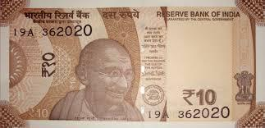 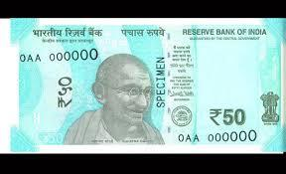

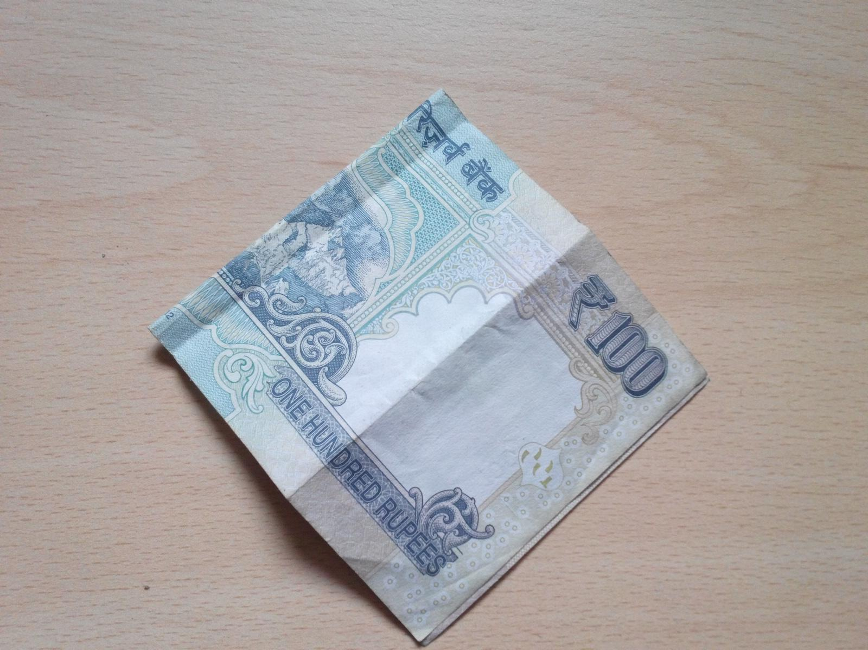 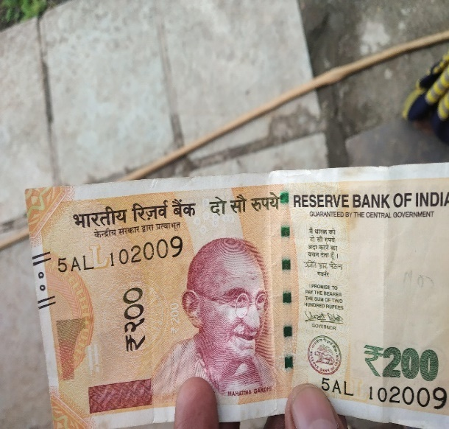

Fig 2 Real Indian Currency Data set

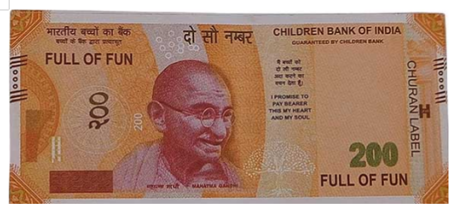 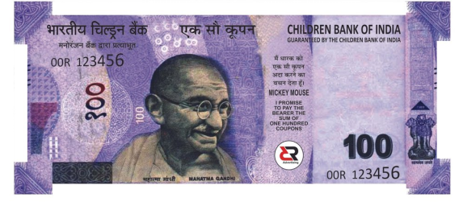

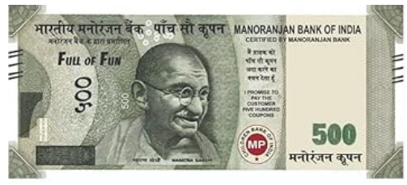 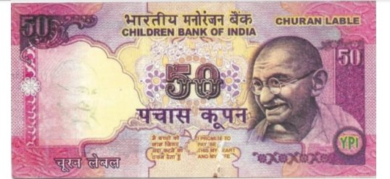

Fig 3 Fake Indian Currency Data set

2. Data Cleaning

Data cleaning is an essential step to maintain the integrity of the dataset. This process includes: Removing any corrupted or incomplete images that could introduce noise. Eliminating unnecessary columns or features that do not aid in the classification task.

Addressing missing or erroneous entries by either dropping or imputing data. Identifying and removing duplicates to ensure a unique set of training images.

3.Data Augmentation- To address potential class imbalances in the dataset (i.e., the number of fake notes is lower than real notes), data augmentation is applied. This involves generating synthetic images through transformations such as: Rotation: Rotating images by a random angle to simulate various viewing conditions.

Flipping: Horizontal or vertical flips to introduce variety in the dataset. Scaling: Zooming in or out to create different resolutions of currency images. Brightness/Contrast Adjustment: Modifying the lighting conditions under which currency notes might appear. Cropping: Random cropping to emphasize different regions of the currency notes. These techniques help balance the dataset and make the model more resilient to variations in real-world scenarios.

4.Feature Extraction- Feature extraction is an essential process where key security elements of the currency notes are extracted and analyzed. These features include: Watermarks: Subtle patterns embedded in the currency that are difficult to replicate. Security Threads: Embedded metallic threads that are visible when viewed under specific lighting conditions. Micro-lettering: Small text or symbols on the currency that are visible under magnification. Color Patterns: Unique colour combinations that are difficult to reproduce in counterfeit notes. Texture Features: Patterns and textures unique to genuine currency notes, analyzed using texture-based algorithms like Local Binary Patterns (LBP)

5. Data Splitting- The dataset is divided into three parts: training, validation, and testing, typically organized as follows:

Training Set: 70% of the dataset is allocated for training the model. Validation Set: 20% is set aside for validating the model during the training process. Testing Set: 10% is used for the final evaluation to assess the model's performance on data it hasn't seen before. This approach ensures a fair assessment of the model's ability to generalize to new data.

6.Preprocessing for Image- Analysis Images go through several preprocessing steps to standardize them for input into the model: Resizing: All images are resized to a uniform dimension (e.g., 299x299 pixels) to align with the input size required by the machine learning models. Normalization: Pixel values are adjusted to a range between 0 and 1 to facilitate more efficient learning by the model. Noise Reduction: Techniques like Gaussian blur are applied to minimize background noise and emphasize important features. Edge Detection: Methods such as the Canny edge detector are utilized to pinpoint the edges of the currency note and enhance critical features like watermarks and security threads.

7.Model Training - Various machine learning and deep learning models are trained to identify counterfeit currency: Convolutional Neural Networks (CNNs): CNNs are used to automatically learn intricate patterns from the image data, employing layers of convolutions, activations, and pooling to extract features from the currency images.

Xception Model: This deep learning model is based on depthwise separable convolutions and is specifically fine-tuned for detecting features in currency images. These models are trained with an optimizer like sigmoid, along with a learning rate scheduler to ensure effective convergence. The training process involves multiple epochs to refine weights and biases for precise classification

8.Model Evaluation  
After training, the models are evaluated using various metrics:

1. Accuracy: Measures the percentage of correctly classified images.
2. Precision and Recall: Evaluates how well the model identifies fake notes (precision) and how well it detects all fake notes (recall).
3. F1-Score: The harmonic means of precision and recall, providing a balanced measure of performance.
4. Confusion Matrix: A confusion matrix is used to visualize the performance of the model, showing the true positives, true negatives, false positives, and false negatives.

Overfitting and underfitting are checked by comparing the performance of the model on the training and validation datasets.

9.ESP32-CAM Integration:

1. Capture Image (ESP32-CAM): The ESP32-CAM captures an image of the currency note.
2. Preprocess Image (ESP32 or Backend): If necessary, the ESP32-CAM performs basic preprocessing (resize, enhance contrast, etc.). Or, it directly sends the image for advanced processing.
3. Send Image to Backend Server (Wi-Fi): The ESP32-CAM transmits the image to a backend server or cloud for advanced analysis.
4. Model Analysis (Backend): The backend system applies a trained machine learning model (e.g., CNN, Xception) to classify the image as real or fake.
5. Return Result (Backend to ESP32-CAM): The backend sends the classification result (real or fake) to the ESP32-CAM.
6. Display Result (ESP32-CAM): The result is displayed on the ESP32-CAM’s interface or used to trigger an alert.

B. Deep Learning Model Workflow

1. Xception Model-The Xception model, known for its efficiency in image classification tasks, is employed for counterfeit currency detection. The architecture of Xception consists of:

* Input Layer: Accepts the preprocessed and resized currency images.
* Convolutional Layers: Extract key features such as textures, edges, and patterns that are indicative of genuine currency.
* Depth wise Separable Convolutions: The core feature of Xception, helping to improve performance while reducing computational cost.
* Fully Connected Layers: Use the extracted features to classify the images as either genuine or fake.
* Output Layer: Provides the final prediction, outputting the probability of an image being genuine or counterfeit.

The Xception model is fine-tuned using a Binary cross-entropy loss function and the Sigmoidoptimizer. A transfer learning approach is used by initializing the model with pretrained weights, enhancing learning efficiency, especially with limited data.

C. Key Contributions of the Proposed Model

* Data Augmentation and Preprocessing: These techniques help overcome class imbalances and improve model robustness against varied real-world conditions.
* Advanced Feature Extraction: By focusing on unique security features such as watermarks, threads, and micro-lettering, the model is capable of distinguishing counterfeit notes effectively.
* Multiple Model Comparisons: The model provides insights into the strengths of various classifiers, aiding in selecting the most efficient approach.
* Scalability and Real-Time Application: The system is designed to be scalable and deployable in various real-world environments, such as ATMs, mobile applications, and bank verification systems.

1. **IMPLEMENTATION**

The following is the implementation process for the proposed framework in the Fake Indian Currency Detection project. This framework outlines steps from dataset preparation to model deployment.

**A. Dataset Overview**

The dataset used in this design is a collection of images of Indian currency notes, both real and fake. The dataset is split into separate folders, one for real currency and one for fake currency, and is used to train machine learning models to detect counterfeit currency.

**Dataset Preparation:** The dataset is organized into two folders, one for real currency images and one for fake currency images. The dataset is initially loaded into memory, and preprocessing steps are applied to prepare the images for model training.

**Data Exploration:** The dataset consists of images with labels indicating whether the currency is real or fake. A visualization of the distribution of real and fake currency images is displayed, giving insight into the dataset's balance.

**B. Data Preprocessing**

1. **Data Cleaning:** Images are loaded from the dataset, and any irrelevant or corrupted files are removed. Any missing data or images that cannot be processed are handled by ensuring that the dataset contains only valid images for both real and fake currency.
2. **Resizing Images:** The images are resized to a consistent size (e.g., 299x299) to make them compatible with the machine learning model. Image data augmentation is applied to increase dataset size and introduce variability to prevent overfitting, including transformations like rotation, zoom, flipping, and shifting as shown in fig 4.

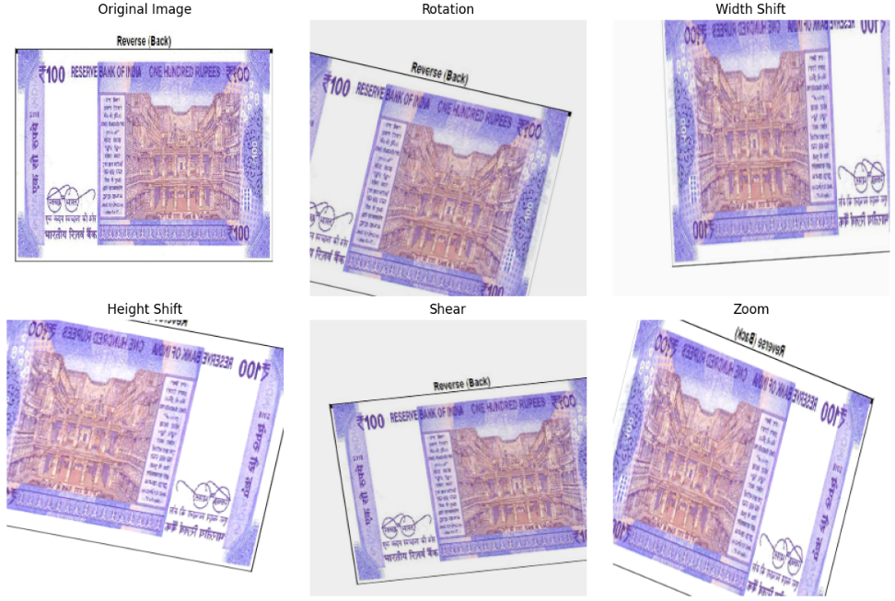

Fig 4 Preprocessing of Rs 100 Indian Note

1. **Normalization:** Image pixel values are normalized to the range [0, 1] by dividing by 255, ensuring that the model can process the data effectively.
2. **Data Splitting:** The dataset is divided into training, validation, and testing sets (e.g., 70% training, 20% validation, and 10% testing) to evaluate the model’s performance. The train_test_split() function from Scikit-learn can be used to divide the data, ensuring that the split is random while maintaining balance between real and fake currency images.

**C. Model Training and Evaluation**

1. **Model Selection:** Various machine learning models are trained to detect fake Indian currency, including Convolutional Neural Networks (CNN) and pre-trained models like Xception, ResNet, and EfficientNet. These models are known for their high performance in image bracket tasks.. There are many features are extracted by Xception Model like edge, Texture, hologram, ink etc, it is Block14_sepconv1 deep separable Convolution Layer that extract main features and classify whether currency is fake or real as Shown in Fig 5, Fig 6 and Fig 7

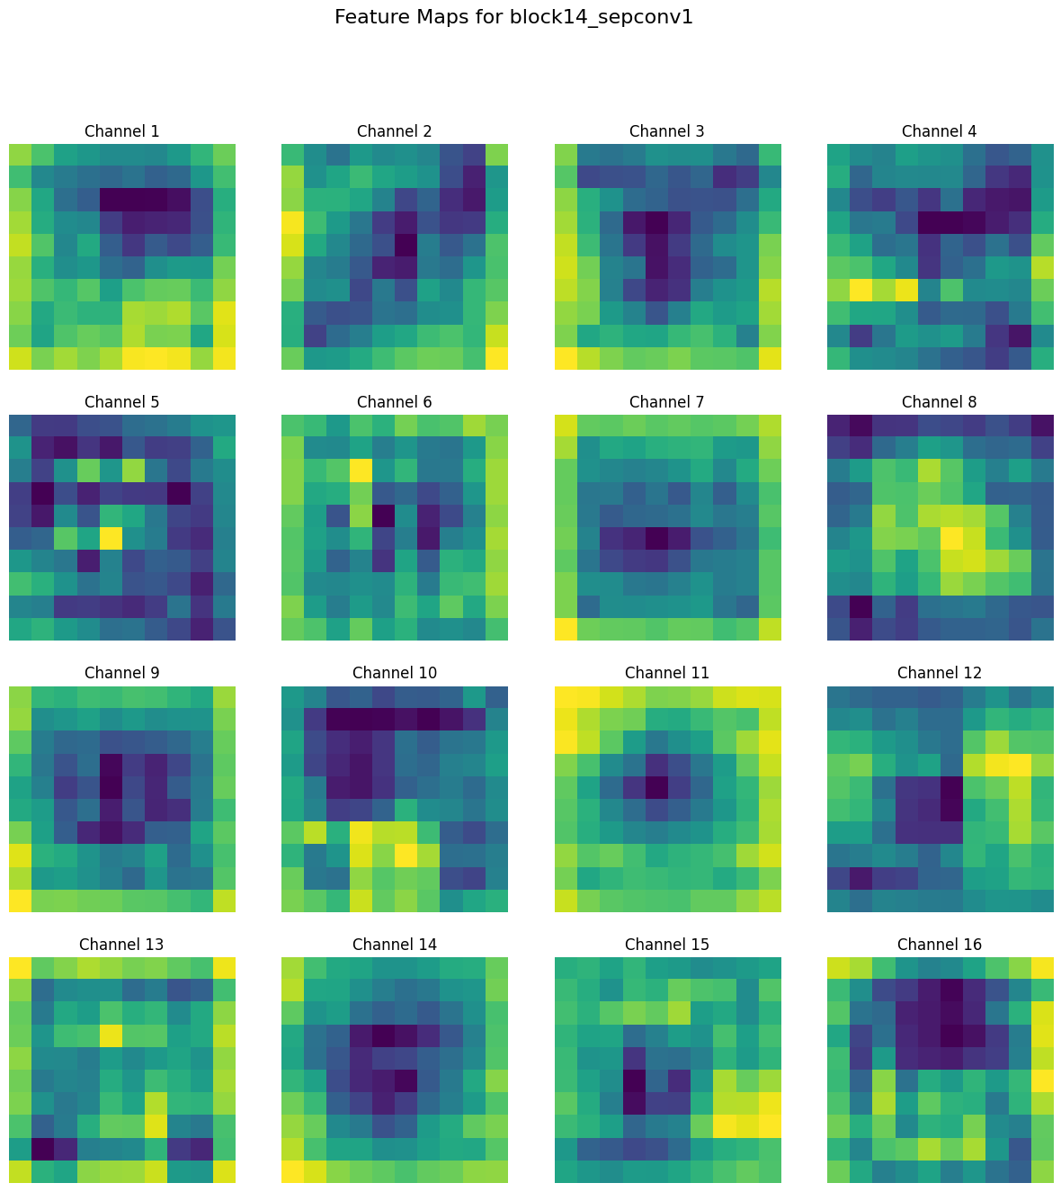

Fig 5 Features Extract by Block14_sepconv1

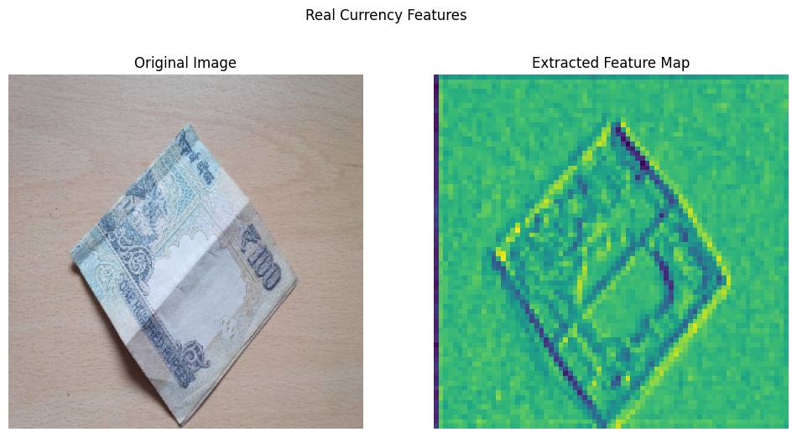

Fig 6 Real Currency Extracted Features Map

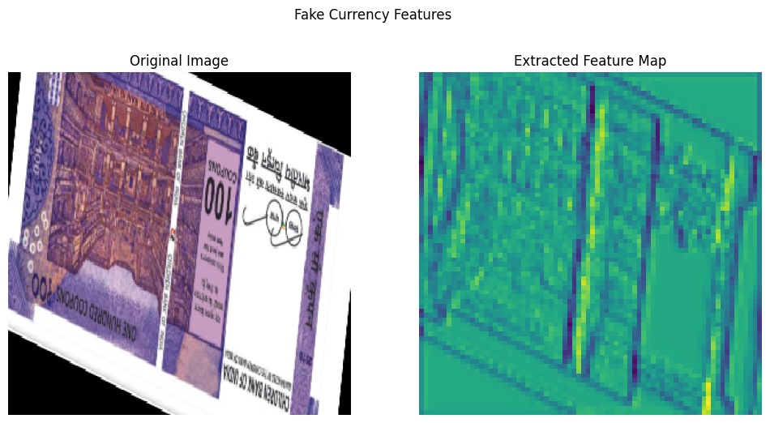

Fig 7 Fake Currency Extracted Features Map

1. **Model Architecture:** A deep learning model is constructed using CNN layers or pre-trained models, followed by fully connected layers. The last layer is a binary classification output layer, where the two classes are "real" and "fake." The model is shown in fig 8

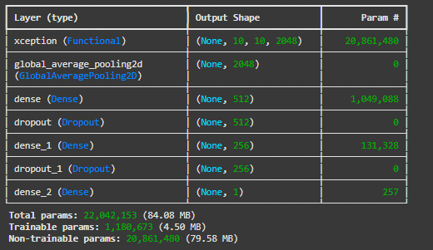

Fig 8 Model Summary

1. **Model Training:** The models are trained on the training dataset using a suitable optimizer (e.g., sigmoid optimizer) and loss function (e.g., binary cross-entropy). Regularization techniques such as dropout and batch normalization are applied to improve model performance and prevent overfitting.
2. **Evaluation:** The models are evaluated based on accuracy, precision, recall, F1-score, and confusion matrix. The confusion matrix provides insight into misclassifications, allowing the model to be fine-tuned to reduce errors as shown in fig 9.

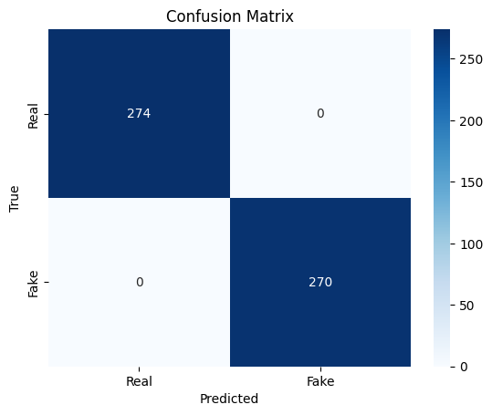

Fig 9 Confusion Matrix

1. **Model Optimization:** Hyperparameter tuning is performed to fine-tune the model's performance, adjusting learning rates, batch sizes, and the number of epochs. Advanced techniques such as transfer learning using pre-trained models (e.g., Xception) can be explored to boost accuracy.
2. **Final Model Selection:** The model with the highest accuracy and lowest error on the validation set is selected for deployment. The selected model is saved for later use in real-world applications.

**D. Deployment**

1. **Model Saving:** The trained model is saved as a file (e.g., model.keras) for later use. This model is then ready to be integrated into a web or mobile application, enabling real-time predictions on images of Indian currency.
2. **Real-time Prediction:** The saved model is loaded, and the application is set up to take images of currency notes as input. The model predicts whether the currency note is real or fake and provides feedback to the user in real-time.
3. **Integration with User Interface:** The model is integrated with a user-friendly interface that allows users to upload currency images. After uploading an image, the system will process it through the model, and the result (real or fake) will be displayed.
4. **Final Testing:** The final system is tested with real-world images to evaluate its robustness and accuracy. If necessary, additional retraining is performed to handle edge cases or improve performance.

**E. Implementing hardware module**

To implement fake Indian currency detection with the ESP32 Camera module as shown in Fig 10, the process starts by capturing images of currency notes using the ESP32-CAM. This camera module, featuring a budget-friendly image sensor, transmits the captured images over Wi-Fi to a central server. The server operates a pre-trained machine learning model, like Xception or a custom CNN, which is designed to classify the images as either real or counterfeit. Prior to inputting images into the model, preprocessing steps such as resizing, normalization, and image augmentation are performed to maintain consistency and enhance robustness. The model is trained on a labeled dataset that includes both real and fake currency images, utilizing frameworks such as Keras or TensorFlow. Once classification is complete, the results are sent back to the ESP32-CAM, offering real-time feedback on the authenticity of the currency. This configuration presents a practical and cost-effective solution for real-time currency verification, making it suitable for integration into ATMs, kiosks, or point-of-sale systems.

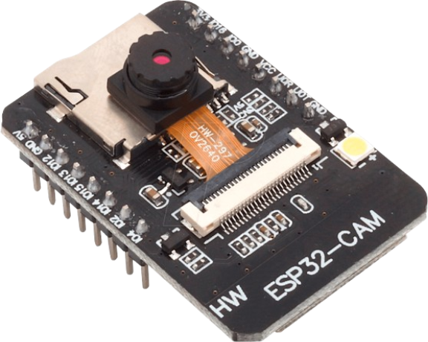

Fig 10 ESP 32 Camera

1. **RESULT ANALYSIS AND DISCUSSION**

The training and testing performance for detecting fake Indian currency was evaluated using **Xception Model** on a desktop computer with the following specifications: 11th generation Ryzen 7000 series processor, 512GB SSD, 8GB RAM, Windows 11, and 2GB NVIDIA GeForce RTX3060 Graphics. Four predefined **Convolutional Neural Network (CNN)** architectures, namely **AlexNet, Xception, DarkNet53, and ResNet50**, were used to test the system's performance on a custom dataset. Data augmentation techniques, including **flipping, rotating,** and **scaling**, were applied to training and testing images before extracting features. The average accuracy of the four CNN models was compared. The **predicted class** and **confusion matrix** generated using ResNet50, DarkNet53, AlexNet, and Xception. In Table II gives the True Positive, True Negative, False positive, False Negative and Accuracy values for four predefined networks. The Table III shows the Precision, Recall rate, F-Measure, Specificity and Youden Index for four predefined networks. The Xception achieves highest accuracy i.e 99.99% compared with the Alexnet, Darknet53 and Resnet50. The Alexnet achieves good Precision rate 80.76%. The Resnet50 and Darknet53 obtain 87.62% Recall Rate. Interms of F-Measure Xception got 0.99. The Specificity of Xception is 89.10%.The following performance metrics were calculated for each model: **True Positive (TP), True Negative (TN), False Positive (FP), False Negative (FN), Accuracy in equation 3, Precision in equation 1, Recall Rate in equation 2, F1-Measure in equation 4** formula shown in Table 1 and for Xception model the graph of performance Shown in fig 11.

|  |  |  |
| --- | --- | --- |
| **Label** | **Formula** |  |
| **Precision** | True Positives (TP)  False Positives (FP)+True Positives (TP)​ | Equation 1 |
| **Recall** | True Positives (TP)  False Negatives (FN)+True Positives (TP)​ | Equation 2 |
| **Accuracy** | True Positives (TP)+True Negatives (TN)​  Total Cases (TP + TN + FP + FN) | Equation 3 |
| **F1 Score** | 2 X Precision X Recall  Precision + Recall | Equation4 |

**Table I.** Formula Table of Precision Recall Accuracy and F1 Score

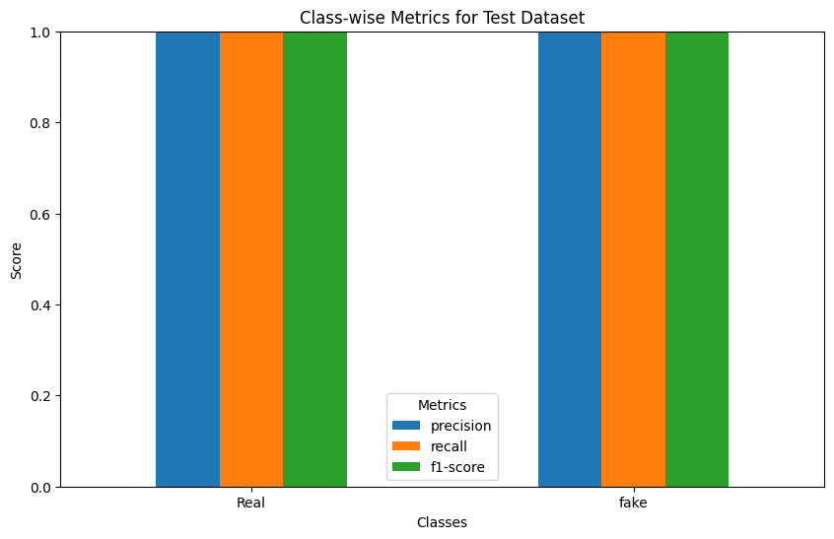

Fig 11 Performance Chart of Xception Model

**TABLE II.** T P,FP,FN,TN AND ACCURACY COMPARISON OF FOUR PREDEFINED NETWORKS

|  |  |  |  |  |  |
| --- | --- | --- | --- | --- | --- |
| **Network** | **True Positive (TP)** | **False Positive (FP)** | **False Negative (FP)** | **Ture Negative(TN)** | **Accuracy** |
| Darknet53 | 185 | 13 | 51 | 165 | 72.04 |
| Alexnet | 180 | 12 | 55 | 195 | 65.15 |
| Resnet50 | 210 | 26 | 59 | 225 | 80.94 |
| Xception | 274 | 00 | 00 | 270 | 99.99 |

**TABLE III**. PRECION, RECALL, F-MEASURE, SPECIFICITY AND YOUDEN INDEX OF FOUR PREDEFINED NETWORKS

|  |  |  |  |  |  |
| --- | --- | --- | --- | --- | --- |
| **Network** | **Precision** | **Recall** | **F1**  **Measure** | **Specificity** | **Youden**  **Index** |
| Darknet53 | 77.57 | 87.62 | 0.57 | 74.25 | 29.6 |
| Alexnet | 80.76 | 43.29 | 0.55 | 88.11 | 31.74 |
| Resnet50 | 76.77 | 87.62 | 0.59 | 74.25 | 28.97 |
| Xception | 99.99 | 99.99 | 0.99 | 89.10 | 88.67 |

1. **CONCLUSION**

Detection of fake Indian currency notes has challenged many in their lives. It has affected public trust as well as the economy and overall stability within the financial sector. Manual fake note detection methods when used bring a lot of errors and inefficiencies to the whole exercise. New-age technologies like image processing, machine learning, and deep learning have thrust counterfeit detection methods into automation and change the way identification becomes a critical process for the identification of counterfeits. Such systems tend to analyze some of these complicated high-security features of notes, such as watermarks, micro-lettering, security threads, and optically variable ink, with accuracy and reliability.

Recent investigation into Convolutional Neural Networks (CNNs), like ResNet50, DarkNet53, AlexNet, and Xception, has lent a credible ear as regards achieving a cost-effective amount of accuracy as well as precision levels. Real-time detection systems, mostly mobile-type compatible applications, have brought places to people, businesses, and financial institutions. Based on this, some challenges such as lighting conditions variability, data scarcity, and high utilization make it an area of further research and improvement.

The future of heavy, lightweight and scalable models while introducing blockchain or other secure technologies boosts their potential capability for detecting counterfeits. With that continuous innovation and improvement of these systems, it would reduce the possibility of circulation of fake currencies in a secure and trustworthy financial ecosystem.

**REFERENCES**

[1] Zahid Ahmed, Sabina Yasmin, Md Nahidul Islam, Raihan Uddin Ahmed “Image Processing Based Feature Extraction of Bangladesh Banknotes”.

[2] Hassanpour,H., Yaseri, A. and Ardeshir G.: “Feature extraction for paper currency Recognition” In International Symposium on Signal Processing and its Application (ISSPA) Sharjah.

[3] R.C.Gonz alez and R.E.Woods, Digital Image Processing,2nd ed.,Prentie Hall,2002 B.Manjunath and W.Ma,”texture features for browsing and retrieval of image data,”IEEE Trans.Pattern Anal .

[4] Mriganka Gogoi, et al.,”Automatic Indian Currency Denomination Recognition System based onArtificial Neural Network”, 978-1-4799-5991-4/15©2015 IEEE.

[5] Hariri, Elham. Hariri,Mahdi . "Persian Banknote detection methods and its imperfections identifies."

[6] Amol A. Shirsath, S. D. Bharkad, A Review of Paper Currency Recognition System, IOSR Journal of Computer Engineering (IOSR-JCE) e-ISSN: 2278-0661, p- ISSN: 2278-8727Volume 10, Issue 1 (Mar. - Apr. 2013).

[7] Yongjiao Liu, Jianbiao He, and Min Li. “New and old banknote recognition based on convolutional neural network”. In: Proceedings of the 2018 International Conference on Mathematics and Statistics. 2018, pp. 92–97.

[8] Tripathi, Milan. “Analysis of Convolutional Neural Network based Image Classification Techniques.” Journal of Innovative Image Processing (JIIP) 3, no. 02 (2021): 100-117.

[9] Chen, Joy Iong-Zong, and Kong-Long Lai. “Deep Convolution Neural Network Model for Credit-Card Fraud Detection and Alert.” Journal of Artificial Intelligence 3, no. 02 (2021): 101-112

[10] Krizhevsky, Alex; Sutskever, Ilya; Hinton, Geoffrey E. (2017-05- 24). "ImageNet classification with deep convolutional neural networks" . Communications of the ACM.**60** (6): pp. 84–90.

[11] Redmon, J. and Farhadi, “A. YOLO9000: better, faster, stronger,” arXiv preprint, 2017.

[12] He, Kaiming, Xiangyu Zhang, Shaoqing Ren, and Jian Sun. "Deep residual learning for image recognition." In Proceedings of the IEEE conference on computer vision and pattern recognition, pp. 770-778. 2001